**Hospital Resources and Room Utilization**

**Front End**

* List of Hospital with Room Availability
* List of Hospital with Available Medicines
* List of Hospital with Available Oxygen tanks
* Hospital Contact Information Directory
* View Notice Board

**Login**

**Admin Dashboard**

* Number of hospitals
* Total Bed Capacity
* Occupied Beds
* Beds Available

**Hospital Information**

* Hospital name
* Complete Address
* Contact Information
* Email Address
* Total Bed Capacity
* Bed Capacity Intended for COVID-19
* Remarks

**User Management**

* Username
* Password
* User Type – admin user, hospital user
* Full name
* Designation

**Backup Database**

**Bed Utilization Report By Hospital**

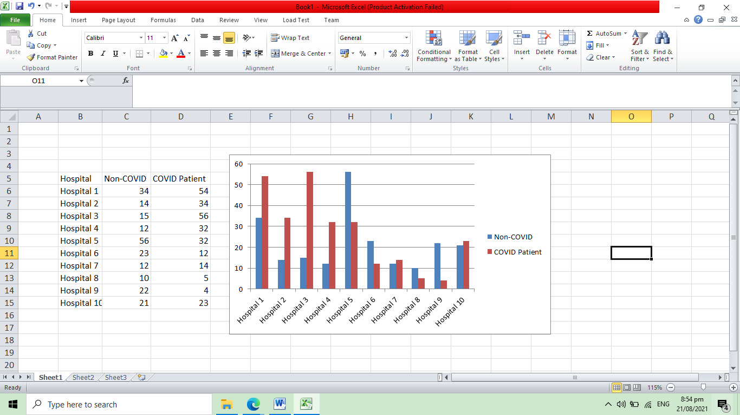

**Oxygen Tank Availability Report By Hospital – with print button**

|  |  |
| --- | --- |
| **Hospital** | **Quantity Available** |
| Hospital 1 | 5 |
| Hospital 2 | 12 |
| Hospital 3 | 14 |
| Hospital 4 | 22 |
| Hospital 5 | 18 |
| Hospital 6 | 31 |
| Hospital 7 | 27 |
| Hospital 8 | 44 |
| Hospital 9 | 15 |
| Hospital 10 | 36 |

**Medicine Used for COVID-19 Availability Report By Hospital – with print button**

|  |  |  |
| --- | --- | --- |
| **Hospital** | **Medicine Name** | **Quantity Available** |
| Hospital 1 | Medicine 1 | 5 |
| Hospital 1 | Medicine 2 | 12 |
| Hospital 2 | Medicine 2 | 14 |
| Hospital 4 | Medicine 1 | 22 |
| Hospital 5 | Medicine 1 | 18 |
| Hospital 6 | Medicine 2 | 31 |
| Hospital 7 | Medicine 3 | 27 |
| Hospital 8 | Medicine 2 | 44 |
| Hospital 9 | Medicine 1 | 15 |
| Hospital 10 | Medicine 1, Medicine 3 | 36 |

**Hospital User**

**Medicine Used for COVID-19**

* Medicine name
* Available in (name of hospital)
* Quantity Available

**Oxygen Tank**

* Tank size
* Available in (name of hospital)
* Quantity Available

**Room/Bed Utilization**

* Bed Number
* Room Type
* COVID Patient (yes, no)
* Occupied (yes, no)

**Notice to the Public**

* Message

**Bed Utilization Report**

